
The Cao Zhongzhi Foundation
www.caozhongzhifoundation.org

Personal Application Form _____No.
____Day Month ___Year
- This form is for the disabled people to apply for wheelchairs or auxiliaries. Applicants must affix original size of front page of Identification card.
- After the application form is completed
2-1 Village or township head, or the cooperative partner to conduct applicant’s initial review
2-2 Village or township head verify whether the ID and photo are matching.
2-3 After check by cooperative partner, personal application form will be forwarded to Taipei Cao Zhongzhi Foundation for final approval

Region： ____ __Province __ District __ County________Village or Town
Name |  | Birth | ___D___M___Y | Gender |  |  | Occupation
Address |  |  |  |  | Post Code

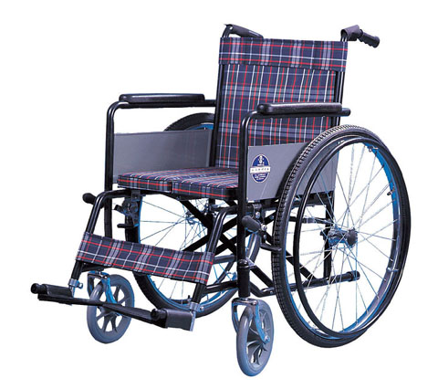  Wheelchair type：Hand push four-wheeled nursing |  |  | Resident certificate，Front photo |  |  |  |  |  |  |  |  |  |  |  |  | Disable person, Photo
Identity of Disabled Person:  □Family poverty □Single-parent family  □Others: |  |  |  |  |  |  |  |  |  | Disability certificate:  □Disability certificate □Family poverty certificate  □Doctor's diagnosis certificate - □chronic illness □legs disabled  □None □Others:
Disability level: □Mild disability □Moderate disability □Severe disability
Application Item: □Crutch □Four-legged wood □Hand push four-wheeled nursing wheelchair
□ Other Auxiliary :
Resident ID No. |  |  |  |  |  |  |  |  |  |  |  |  |  |  |  |  |  |  |  | Applicant  Signature：
Tel No. |  |  |  |  |  |  |  |  |  |  |  |  |  |  |  |  |  |  |  | Applicant  Signature：

Initial review:  Conducting home visit | Review:  Is the application filled in correctly? | Review：  Application Partner | Approve:  The Cao Zhongzhi Foundation
Village or township head, or Cooperative partner  Signature  Date:____D_____M_____Y | Village or township head  Signature:  Date:____D____M____Y | Signature:  Date:___D___M___Y | Signature  Date:___D___M___Y

